

Software Engineering

Social Network

TA-Mohamed Samir



December 6, 2014

**Leader Name: Ahmed Abd El-Fattah Abd El-Naem**

**ID: 20120046**

**IT-1**

**Contacts:**

[**Ahmed.donkl@gmail.com**](mailto:Ahmed.donkl@gmail.com)

**Phone:**

**01093030370**

Contents

Team 3

Document Purpose and Audience 3

System Models 3

System Decomposition 3

Class diagrams 6

Important Algorithm 7

Sequence diagrams 7

Class - Sequence Usage 9

Physical Entity-Relationship Diagram 10

User Interface Design 10

Screen 1 – write post 11

Screen 2 – send message 11

Screen 3 – Login Screen 11

Screen 4 – Sign Up 11

Ownership Report 12

# Team

|  |  |  |  |
| --- | --- | --- | --- |
| **ID** | **Name** | **Email** | **Mobile** |
| 20120046 | Ahmed Abd El-fattah | Ahmed.donkl@gmail.com | 01093030370 |
| 20120014 | Ahmed Badr Sayed | Ahmed.badr636@yahoo.com | 01097839631 |
| 20120044 | Ahmed Abd El-ghafar | Ahmedsoud3@gmail.com | 01062471058 |
| 20120049 | Ahmed Abd El-nasser | Asallan23@outlock.com | 01128409572 |

# Document Purpose and Audience

## Audience

The audience includes the client, the users, the project management, the system analysts (i.e., the developers who participate in the requirements), and the system designers (i.e., the developers who participate in the system design).

## Purpose

The purpose of this document is to give a detailed design of the system for the “back-end API” software for social media. It will illustrate the purpose and complete declaration for the development of this system. It will also explain system constraints, interface and interactions with other external applications.

# System Models

## System Decomposition

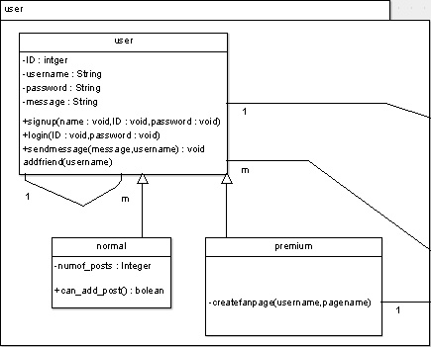

## 

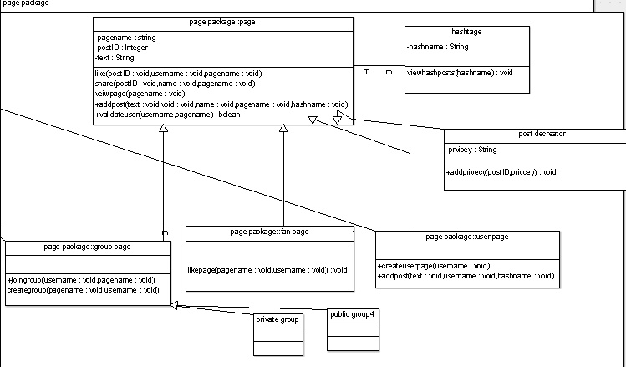

## Class diagrams

## 

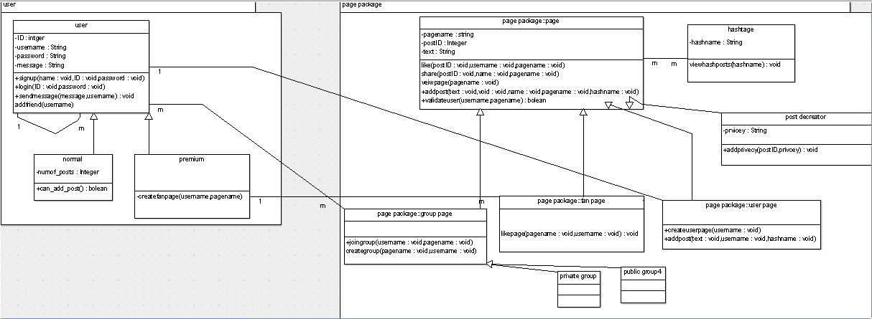

## Sequence diagrams

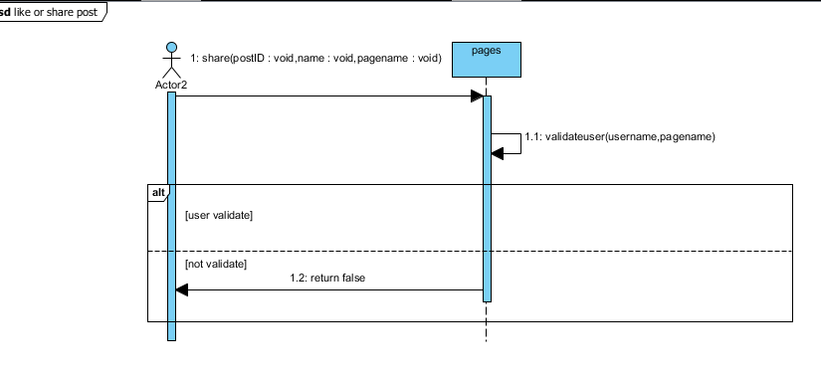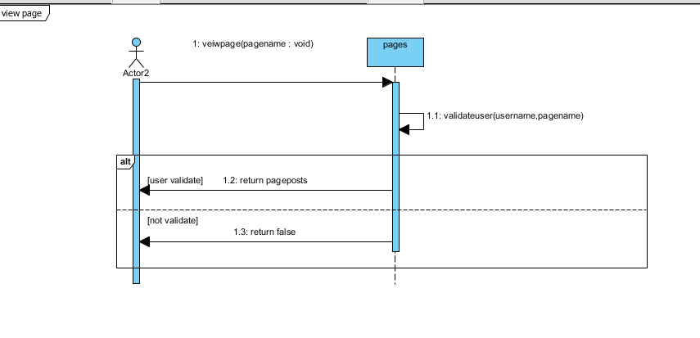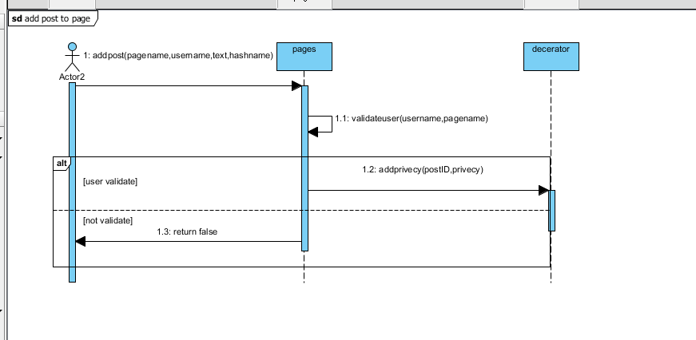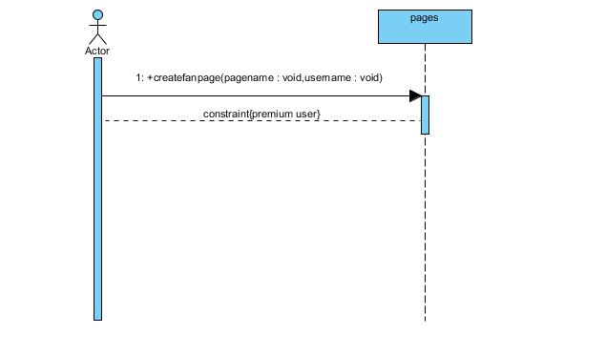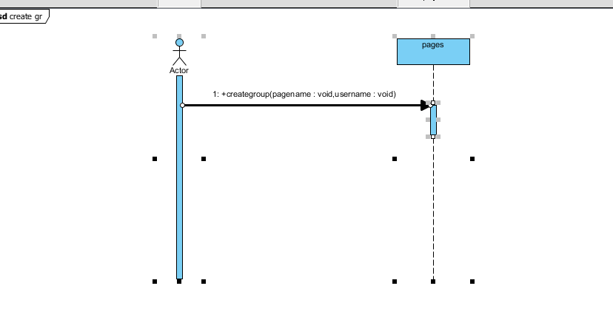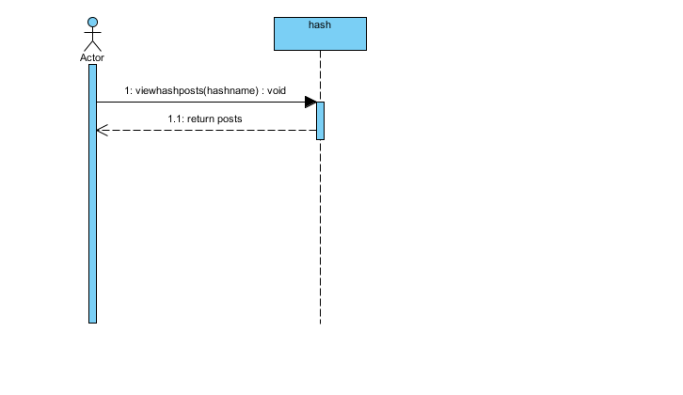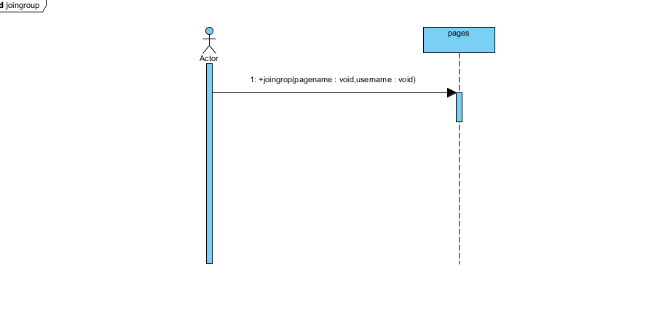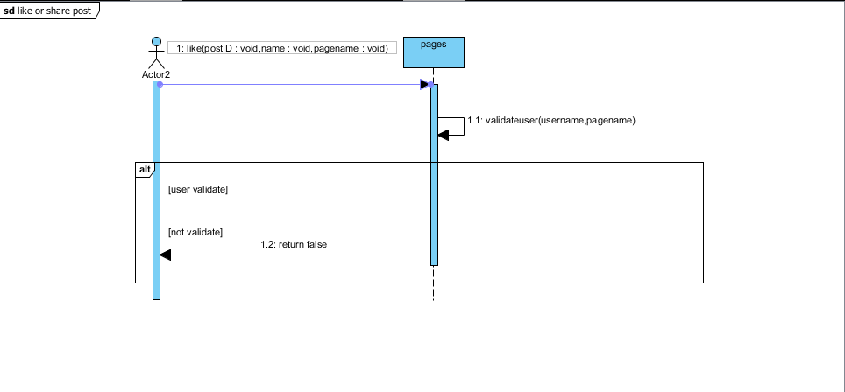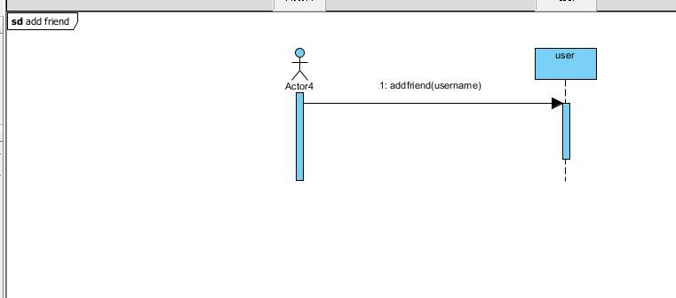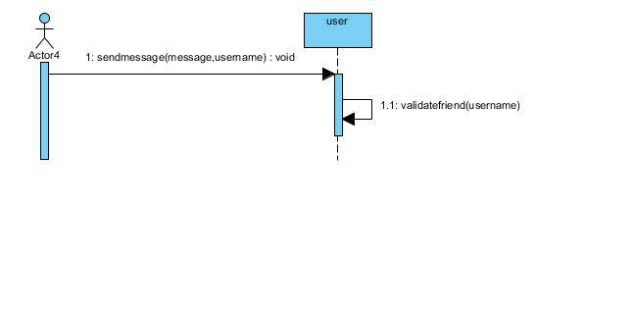

## 

## User Interface Design

### Screen 1 – write post

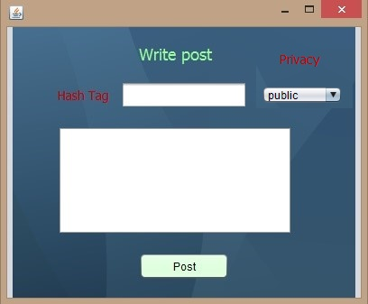

### Screen 2 – send message

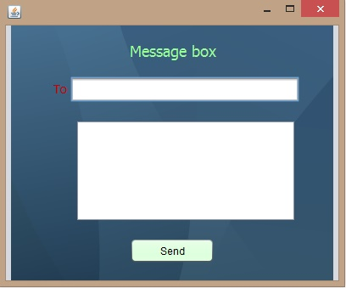

### Screen 3 – Login Screen

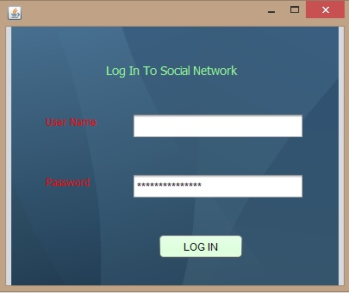

### Screen 4 – Sign Up

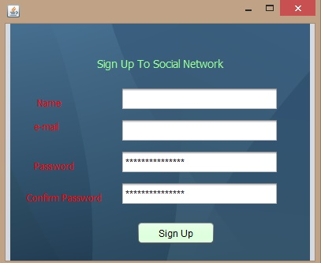

### Screen 5 – hashtag

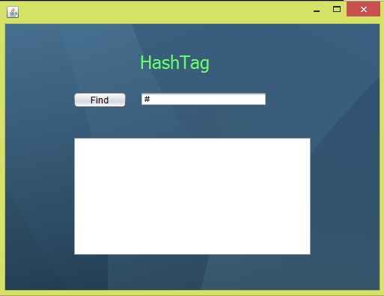

### Screen 6 – home

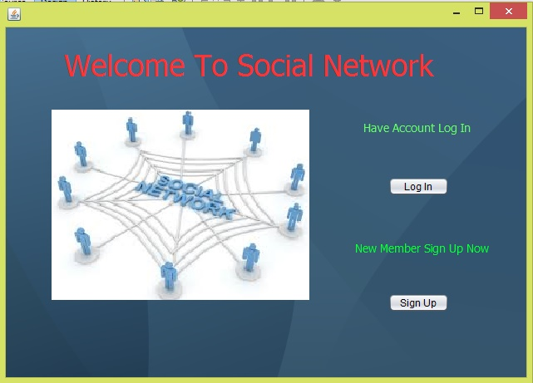

# Ownership Report

|  |  |
| --- | --- |
| **Item** | **Owners** |
| Class diagrams | *Ahmed Abd El-ghafar* |
| System Decomposition | *Ahmed Abd El- Nasser* |
| Sequence diagrams | *Ahmed Badr Sayed* |
| User Interface Design | *Ahmed Abd El=fattah* |